|  |  |  |  |  |  |  |  |  |  |  |  |  |  |
| --- | --- | --- | --- | --- | --- | --- | --- | --- | --- | --- | --- | --- | --- |
|  | Bicubic interpolation | SRGAN-1  (50 epochs) | | SRGAN-1  (150 epochs) | | SRGAN-1  (250 epochs) | | SRGAN-1  (350 epochs) | | SRGAN-1  (450 epochs) | | SRGAN-1  (500 epochs) | |
| RMSE (wind, m/s) | 1,435 | 1,595 | 1,589 | 1,386 | 1,386 | 1,343 | 1,371 | 1,321 | 1,326 | 1,317 | 1,337 | 1,547 | 2,023 |
| RMSE (SLP, hPa) | 0,576 | 0,993 | 0,887 | 0,642 | 0,621 | 0,608 | 0,721 | 0,559 | 0,548 | 0,587 | 0,617 | 0,849 | 1,504 |
| RMSE-95 (m/s) | 1,898 | 2,555 | 2,621 | 2,106 | 2,189 | 2,006 | 2,144 | 1,965 | 2,061 | 1,971 | 2,055 | 2,206 | 2,806 |
| PSNR | 35,159 | 33,365 | 32,287 | 34,711 | 34,210 | 35,590 | 34,182 | 35,351 | 33,594 | 35,152 | 34,521 | 33,705 | 30,909 |

|  |  |  |  |  |  |  |  |  |  |  |  |
| --- | --- | --- | --- | --- | --- | --- | --- | --- | --- | --- | --- |
|  | Bicubic interpolation | CNN  (50 epochs) | | CNN  (150 epochs) | | CNN  (250 epochs) | |  | |  | |
| RMSE (wind, m/s) | 1,435 | 1,520 | 1,517 | 1,369 | 1,374 | 1,338 | 1,408 |  |  |  |  |
| RMSE (SLP, hPa) | 0,576 | 0,917 | 0,811 | 0,634 | 0,608 | 0,643 | 0,754 |  |  |  |  |
| RMSE-95 (m/s) | 1,898 | 2,391 | 2,466 | 2,081 | 2,163 | 2,014 | 2,171 |  |  |  |  |
| PSNR | 35,159 | 34,202 | 32,537 | 34,678 | 33,860 | 35,168 | 34,493 |  |  |  |  |

|  |  |  |  |  |  |  |  |  |  |  |  |
| --- | --- | --- | --- | --- | --- | --- | --- | --- | --- | --- | --- |
|  | Bicubic interpolation | SRGAN-1  (50 epochs) | | CNN  (50 epochs) | | SRGAN-1  (150 epochs) | | CNN  (150 epochs) | | SRGAN-1  (350 epochs) | |
| RMSE (wind, m/s) | 1,435 | 1,595 | 1,589 | 1,520 | 1,517 | 1,386 | 1,386 | 1,369 | 1,374 | 1,321 | 1,326 |
| RMSE (SLP, hPa) | 0,576 | 0,993 | 0,887 | 0,917 | 0,811 | 0,642 | 0,621 | 0,634 | 0,608 | 0,559 | 0,548 |
| RMSE-95 (m/s) | 1,898 | 2,555 | 2,621 | 2,391 | 2,466 | 2,106 | 2,189 | 2,081 | 2,163 | 1,965 | 2,061 |
| PSNR | 35,159 | 33,365 | 32,287 | 34,202 | 32,537 | 34,711 | 34,210 | 34,678 | 33,860 | 35,351 | 33,594 |

SRGAN-1 vs CNN

1 Jan 2010

50 epochs

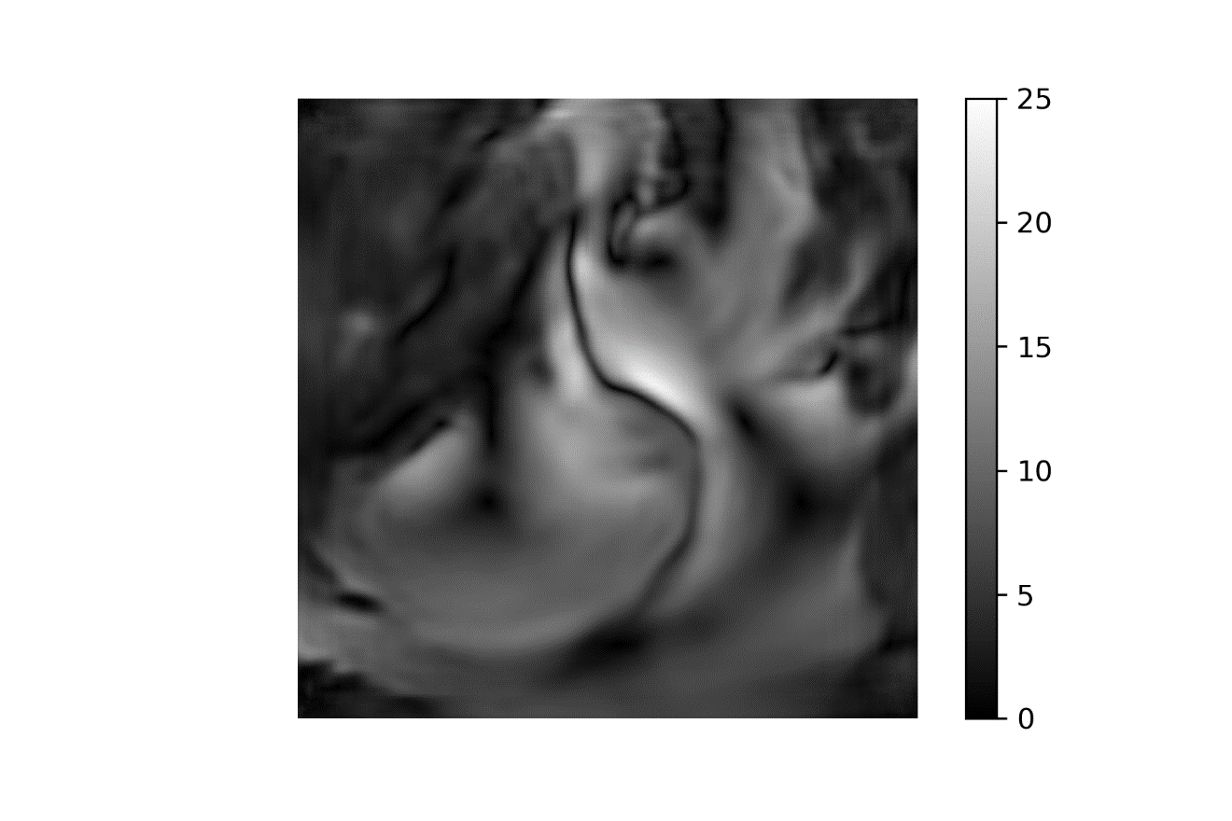 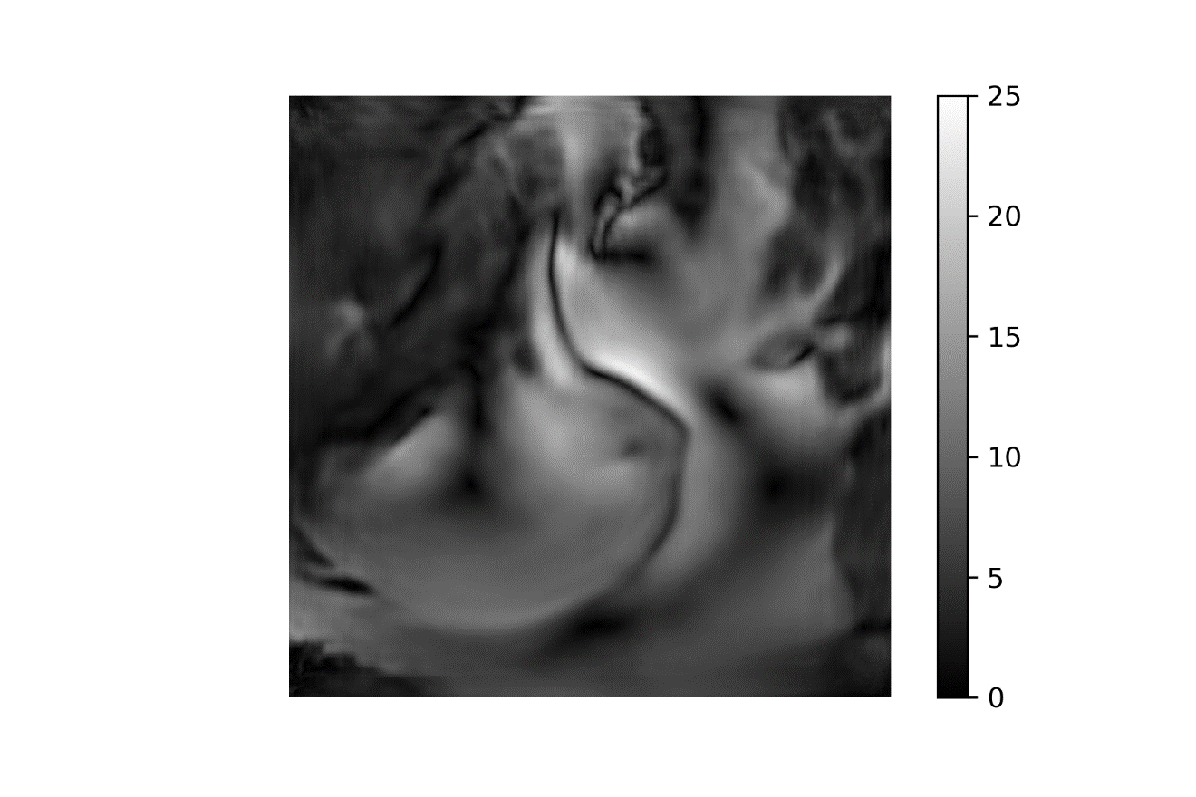

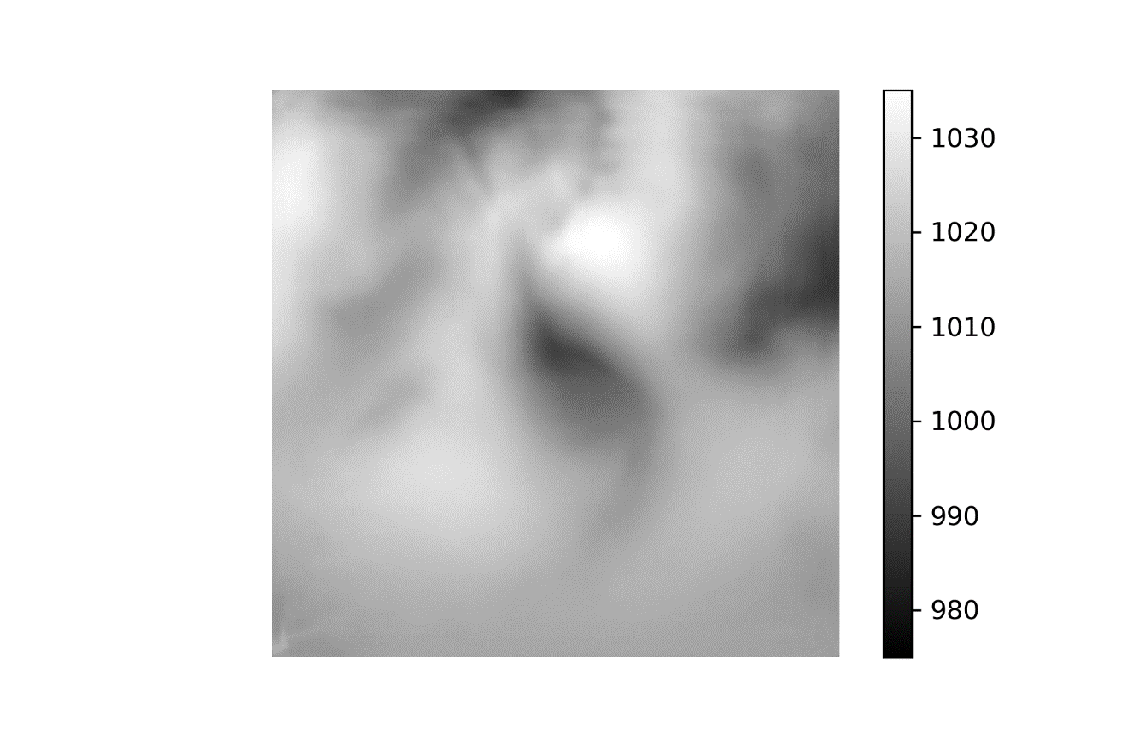 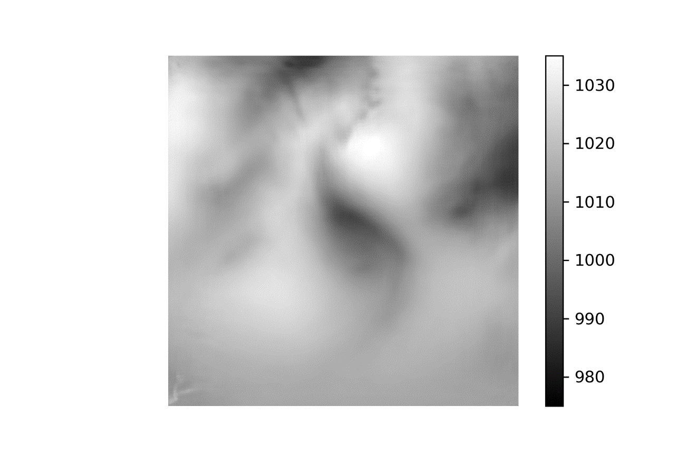

SRGAN-1 vs CNN

1 Jan 2010

150 epochs

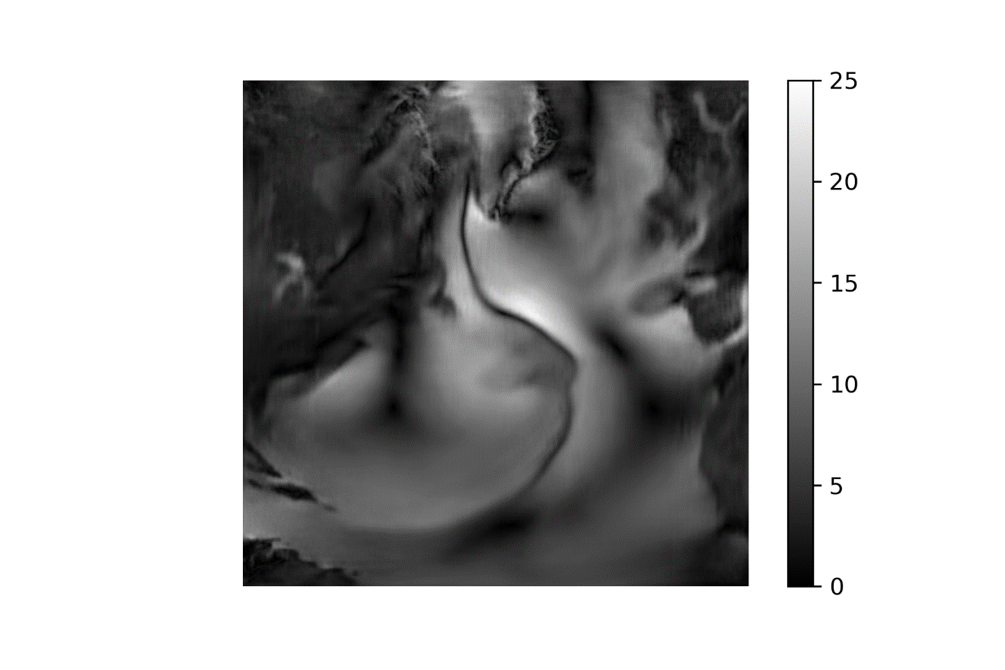 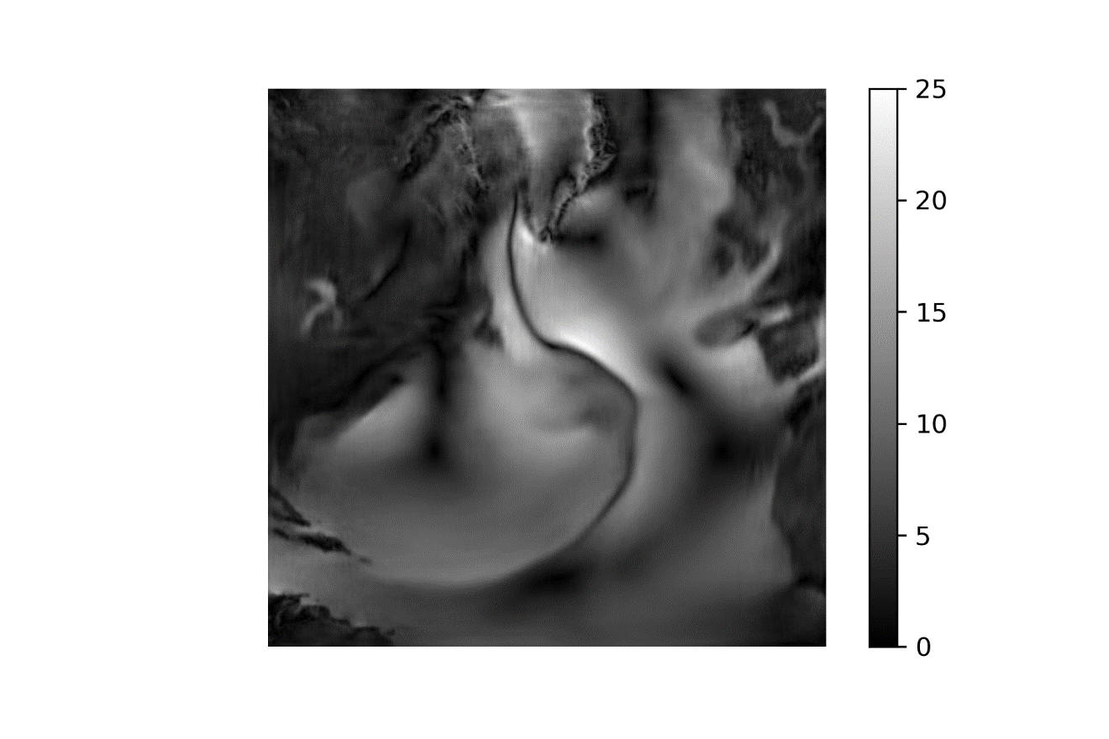

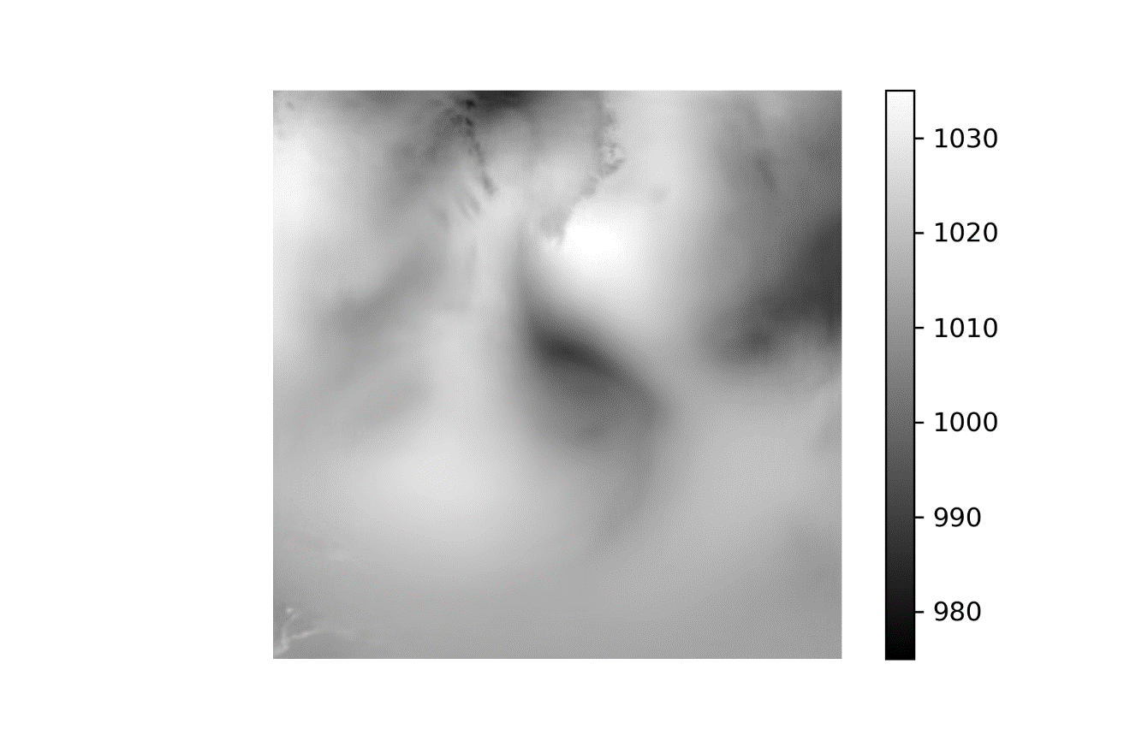 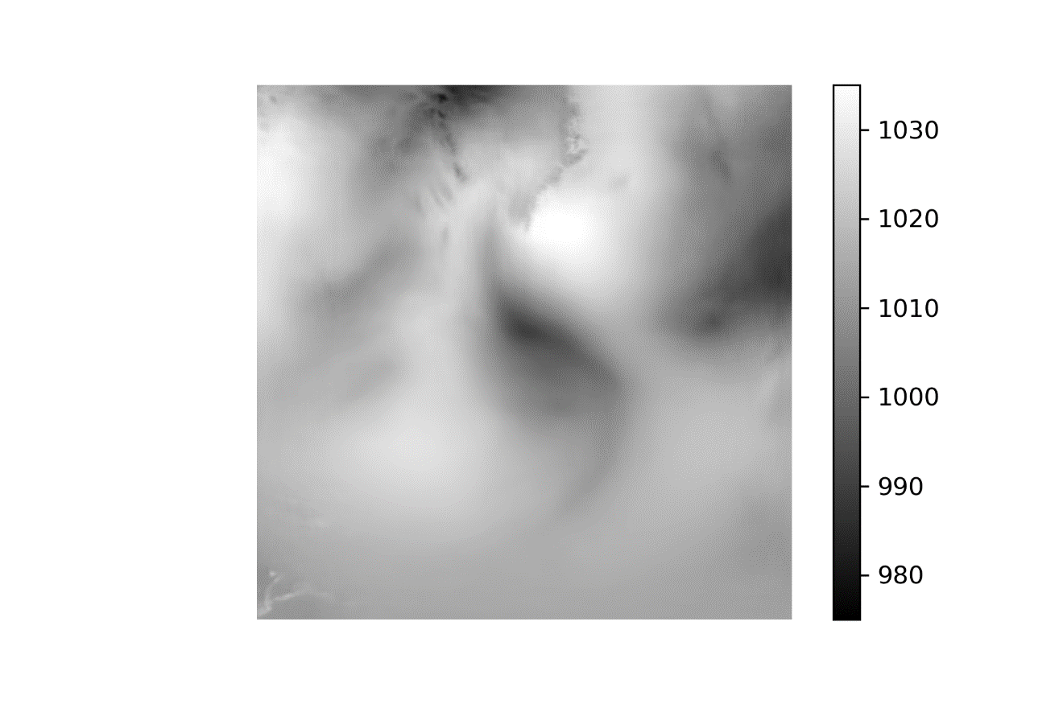

SRGAN-1 vs CNN

1 Jul 2010

50 epochs

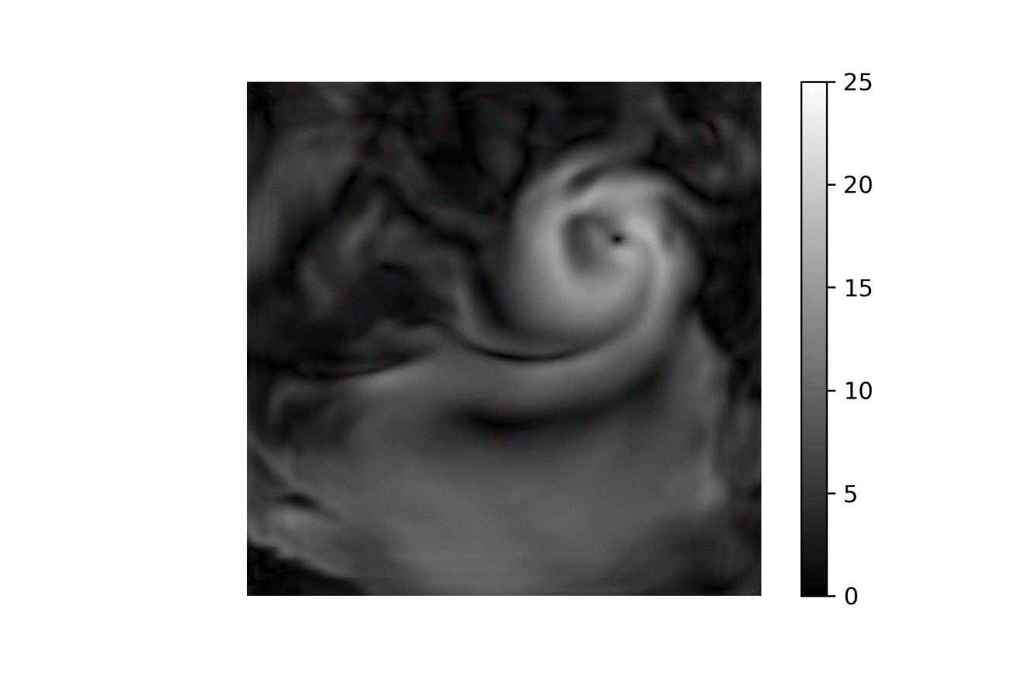 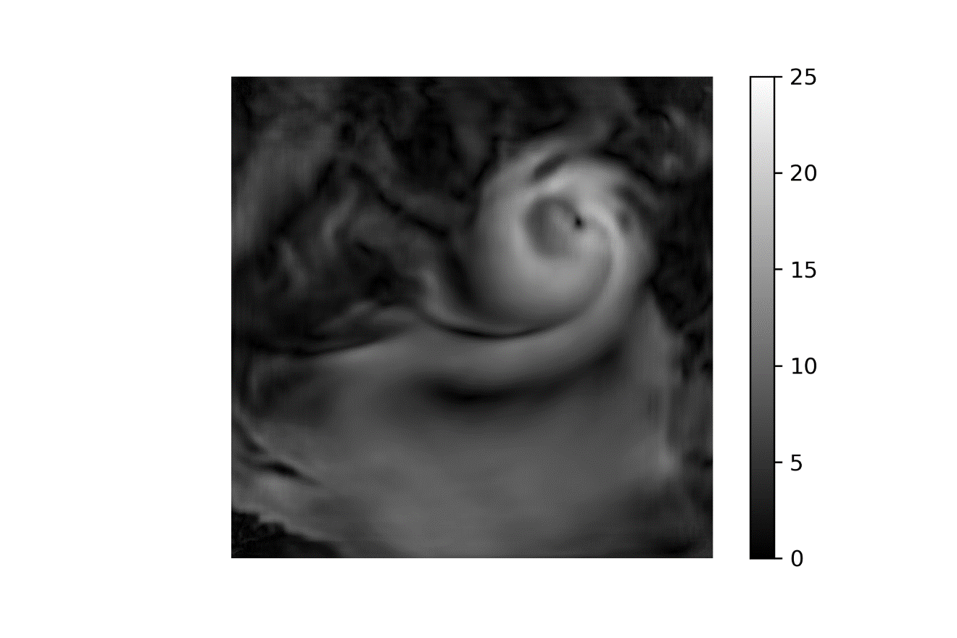

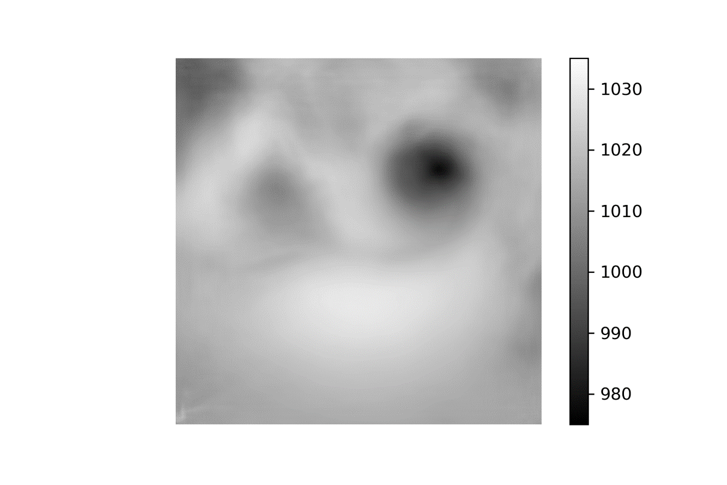 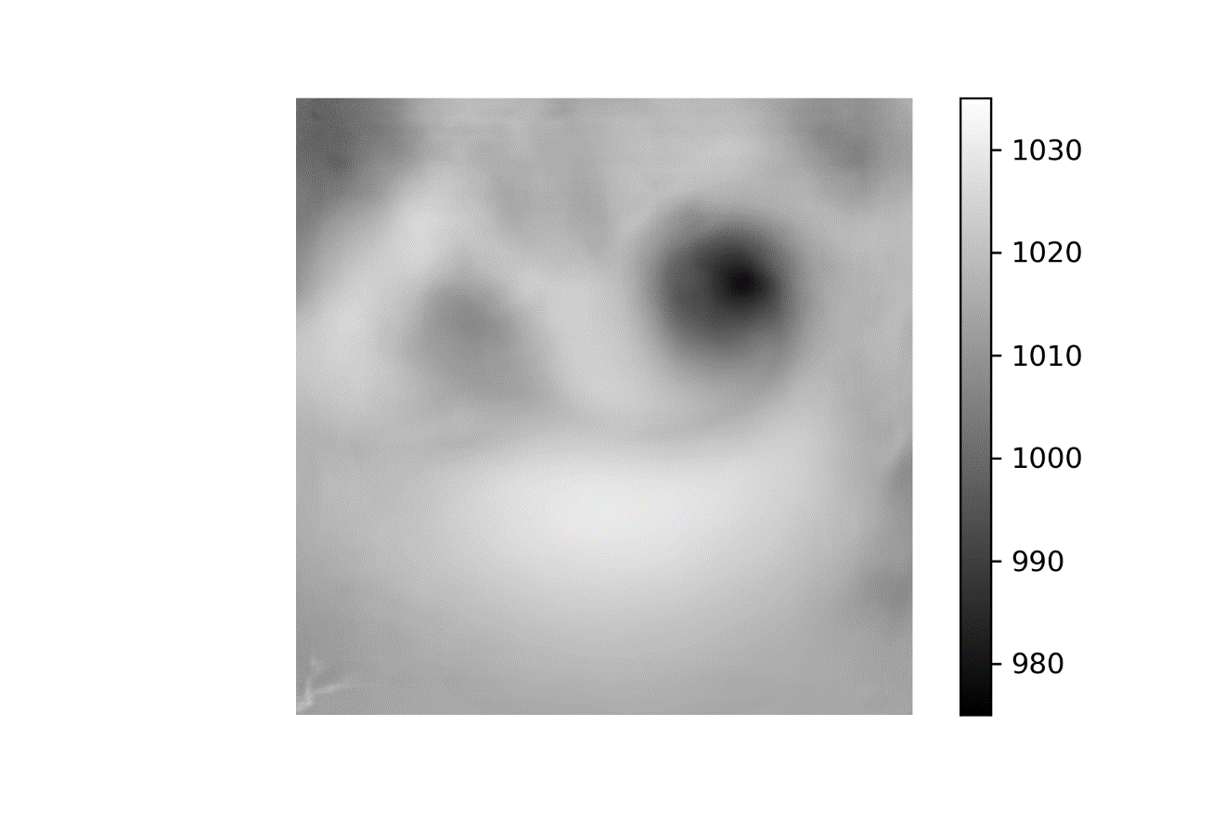

SRGAN-1 vs CNN

1 Jul 2010

150 epochs

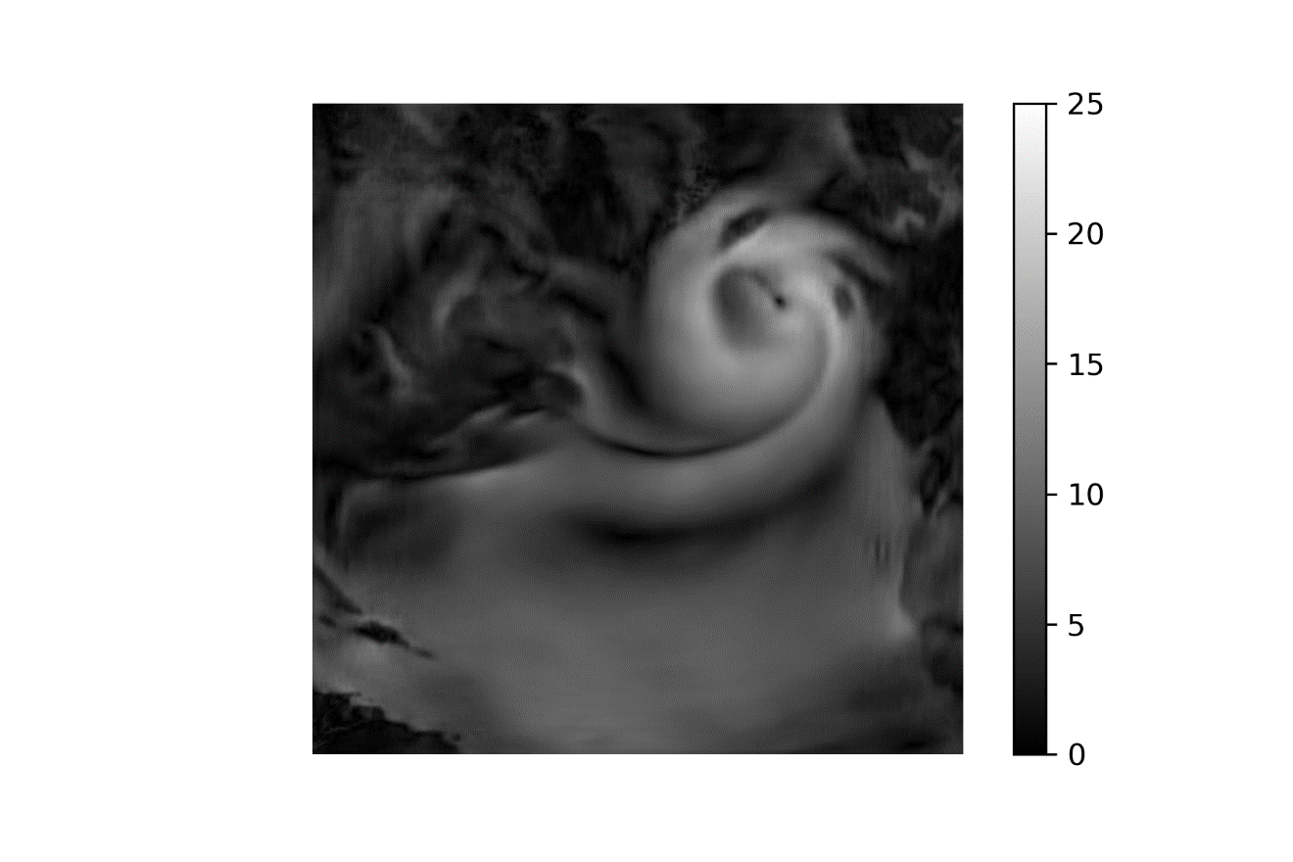 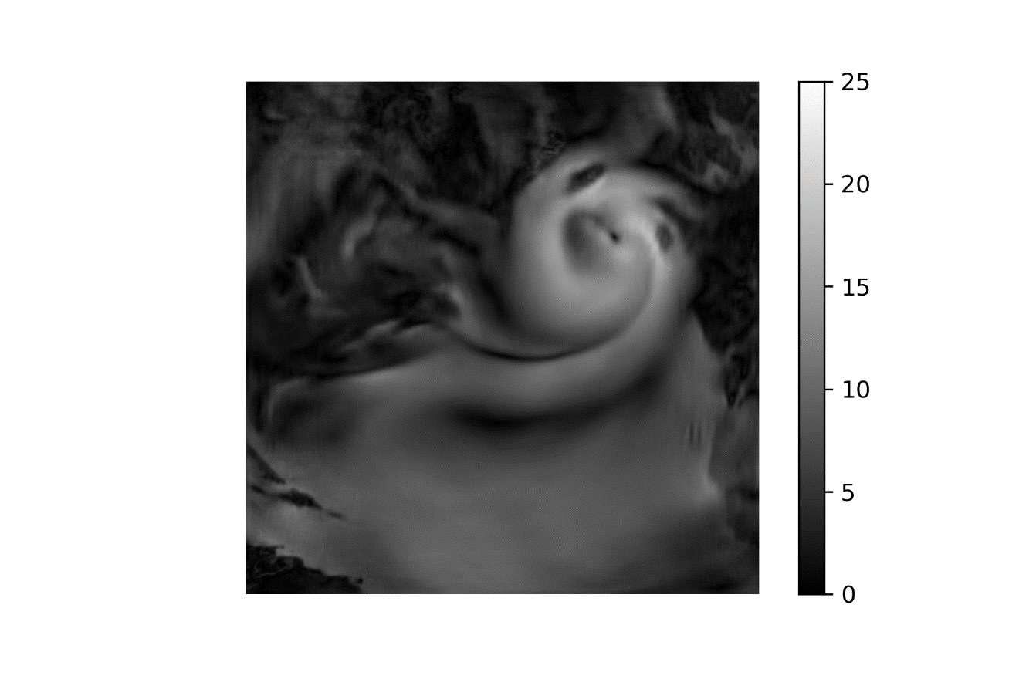

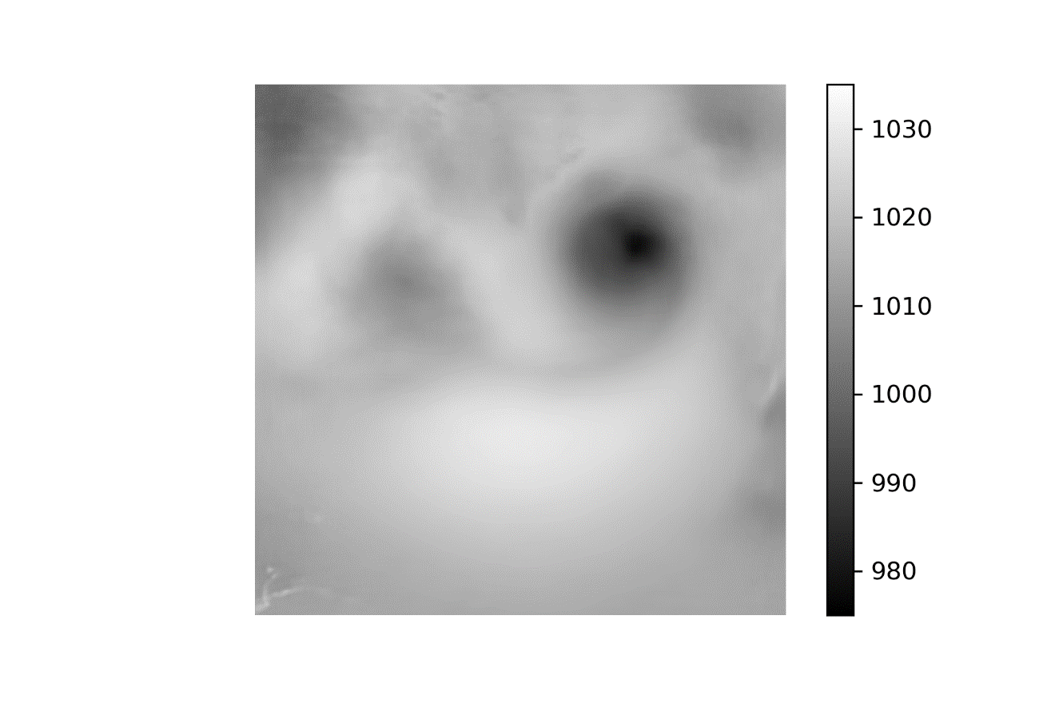 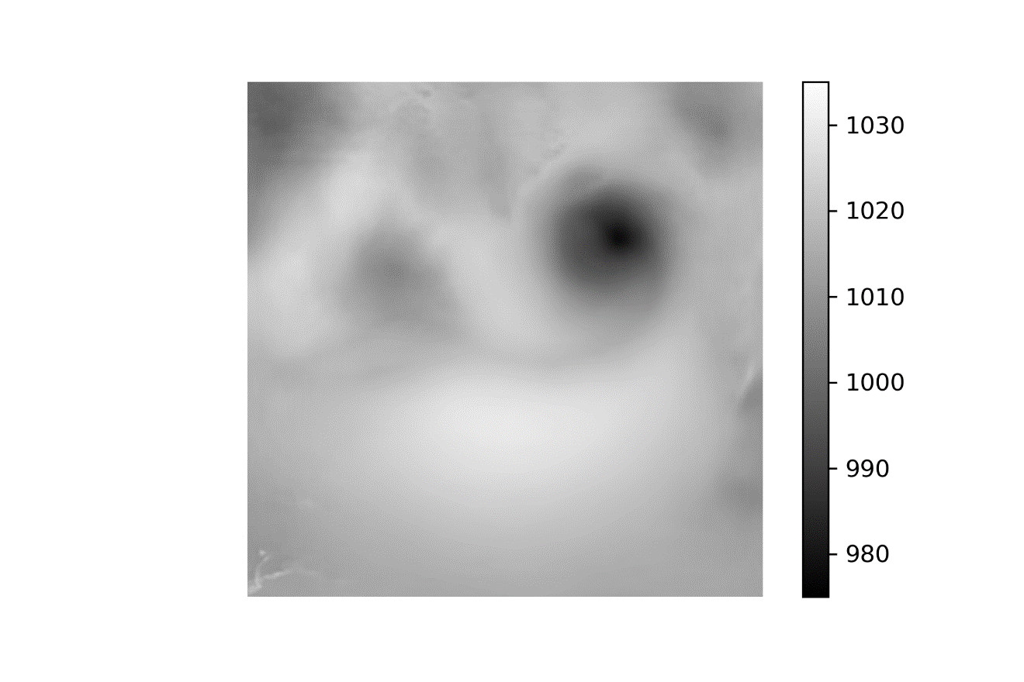

(1 January 2010 Low-Interp-High)

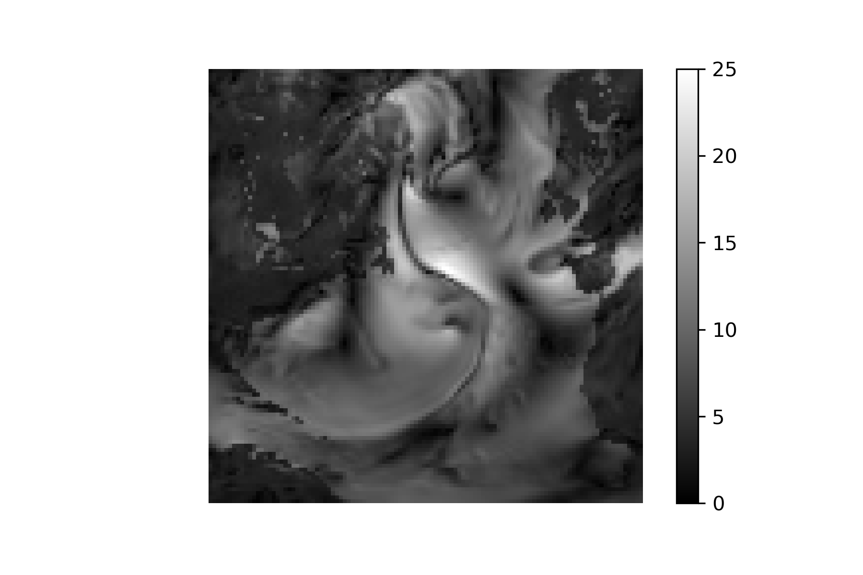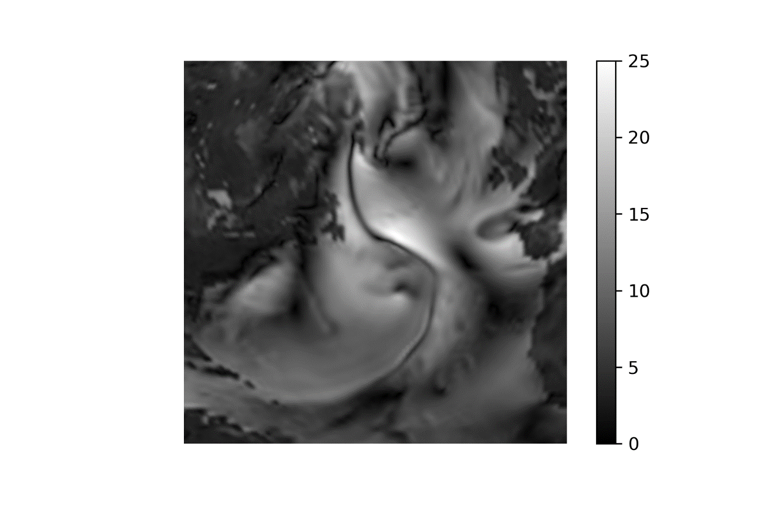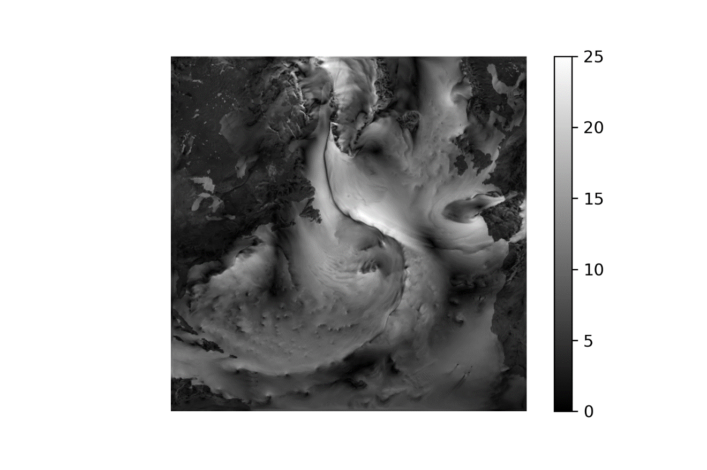

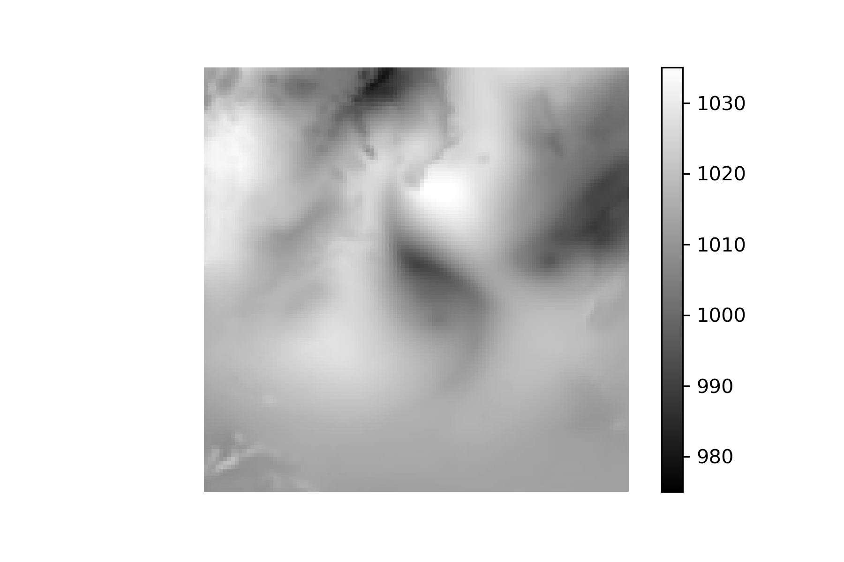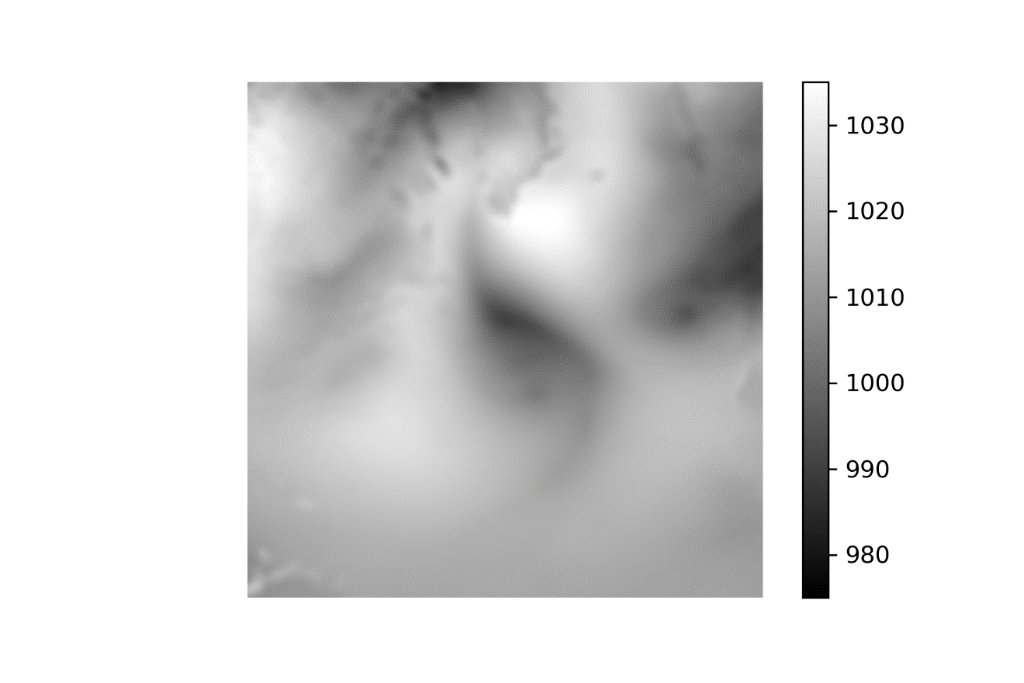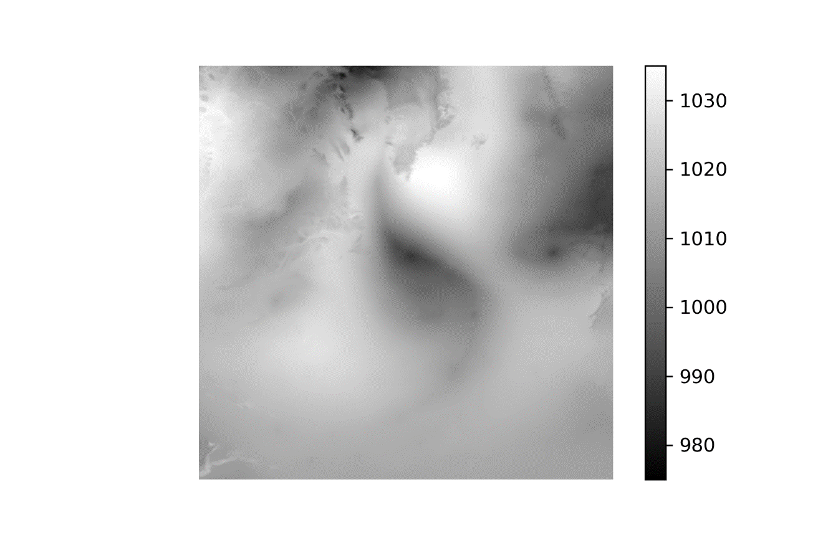

(1 Jul 2010 Low-Interp-High)

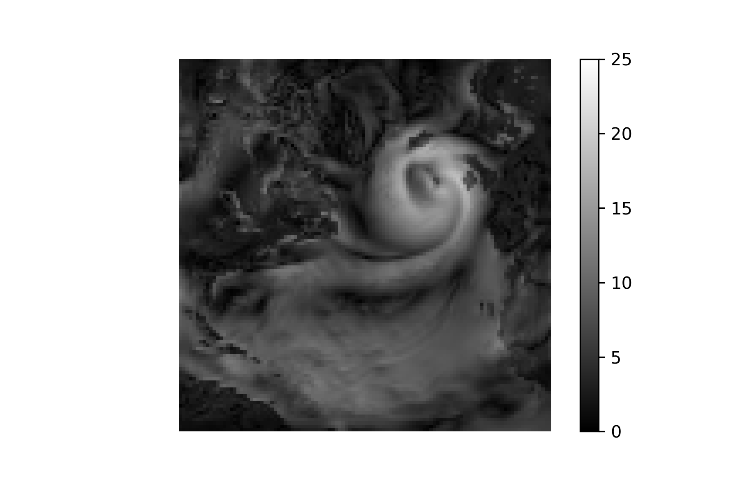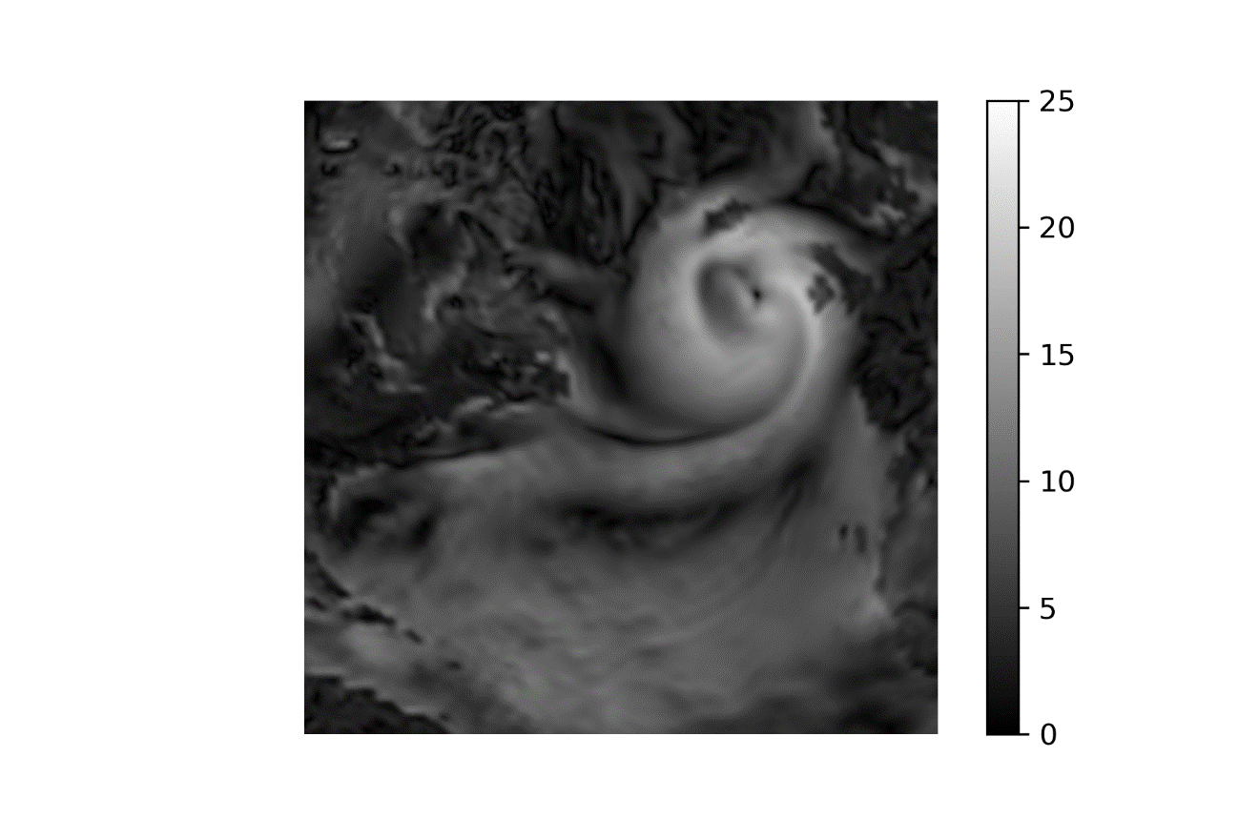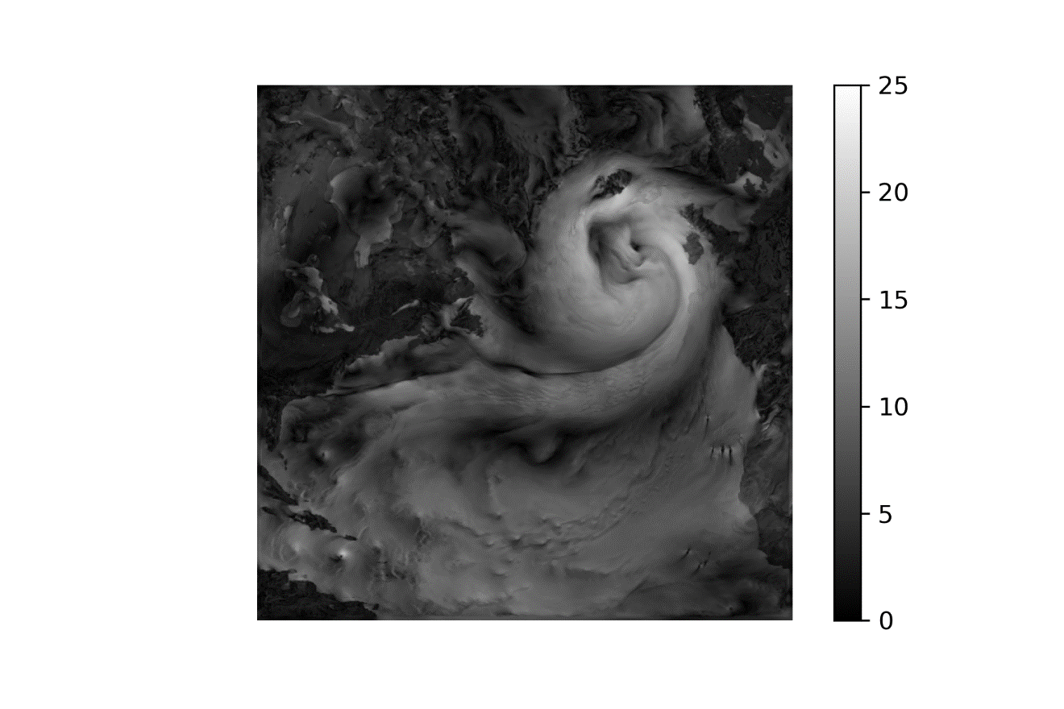

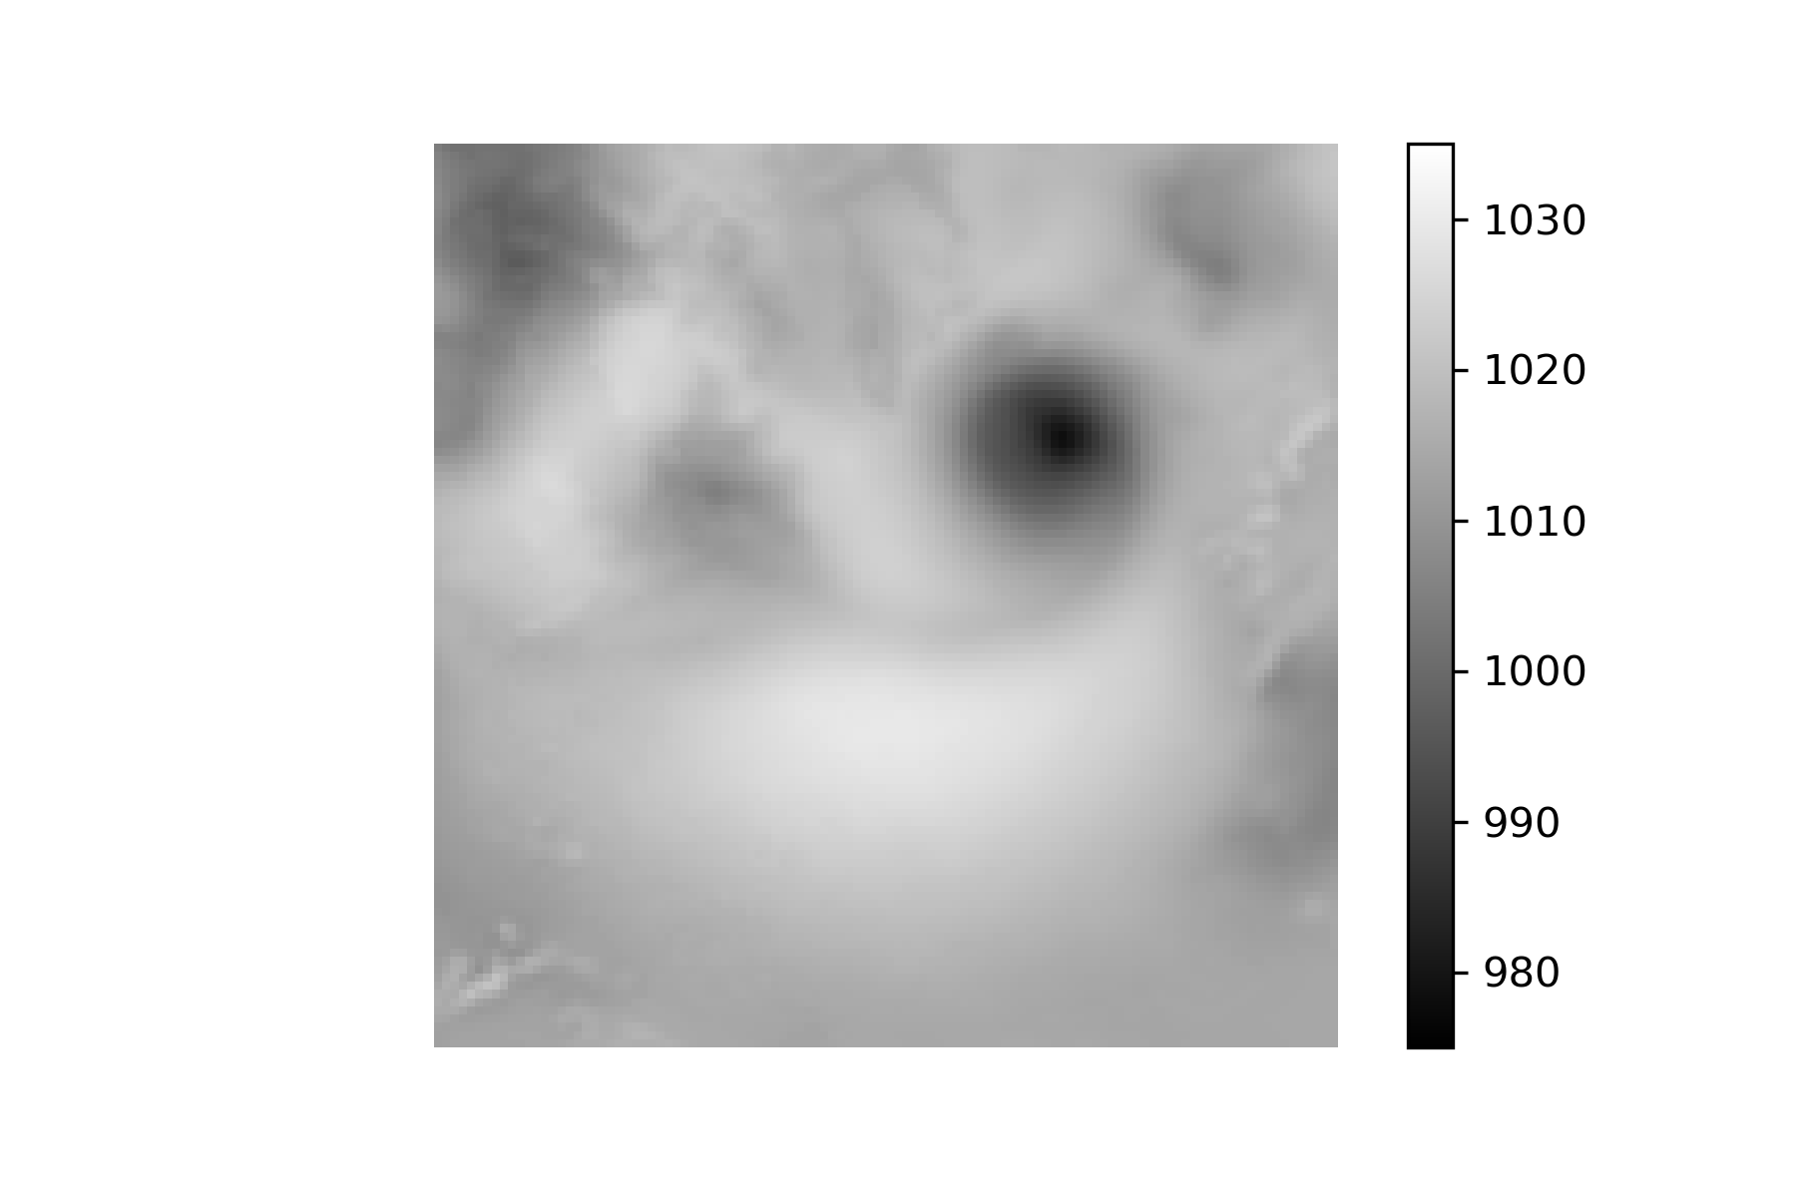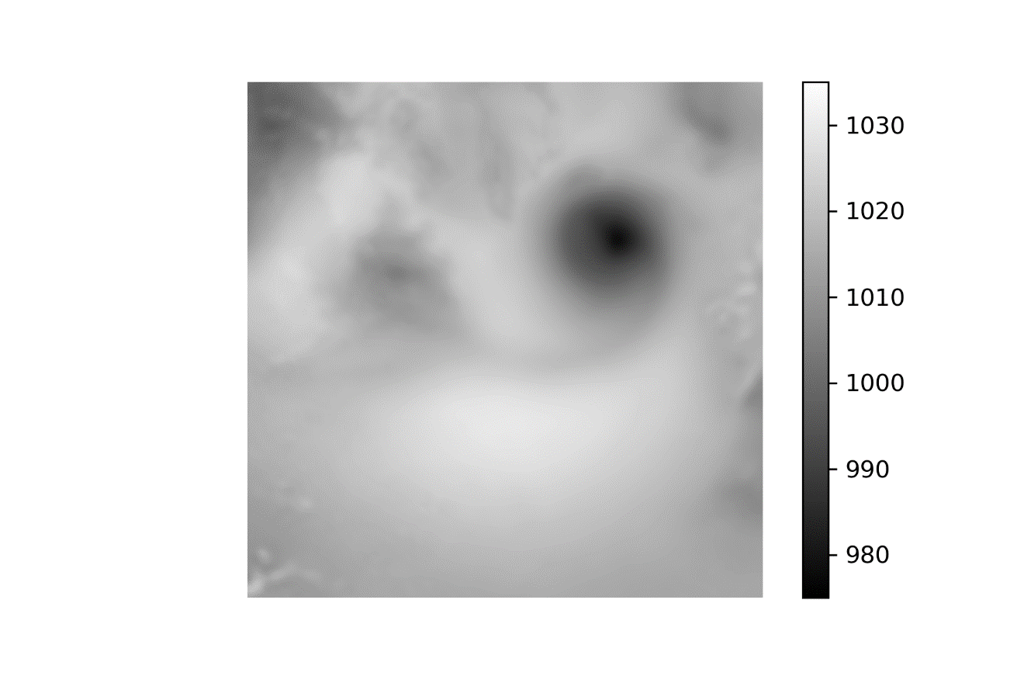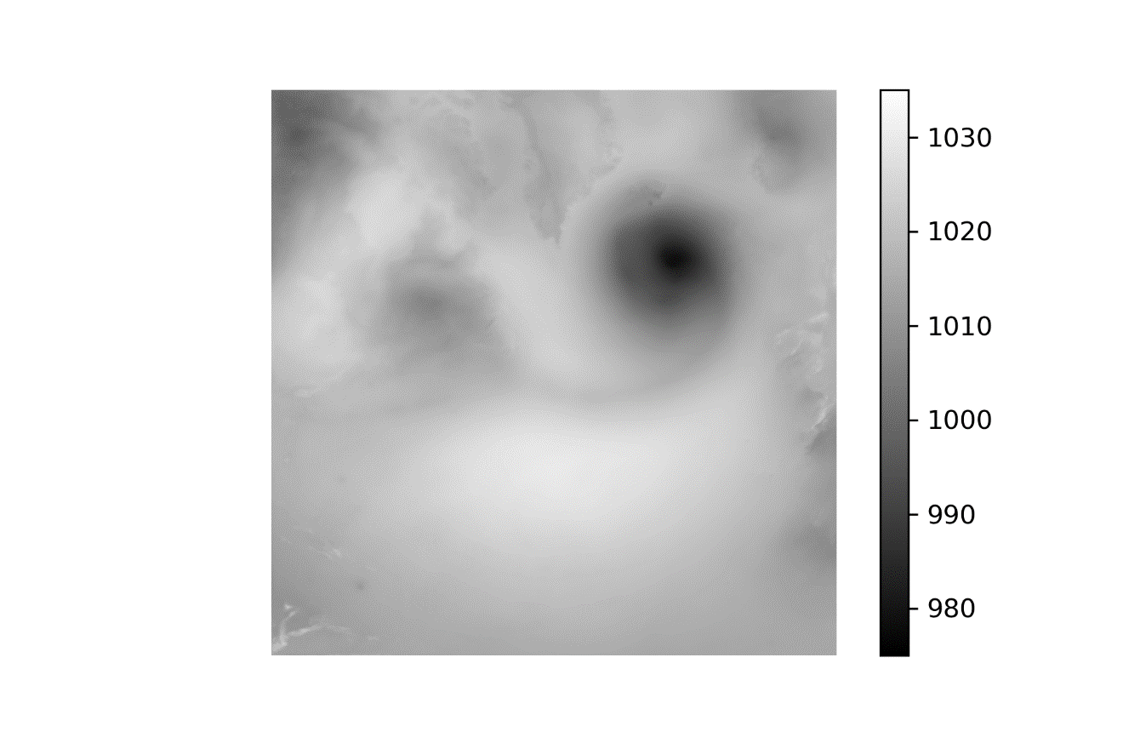

1 Jan 2010 –-SRGAN-1 - 50-150-350-High

 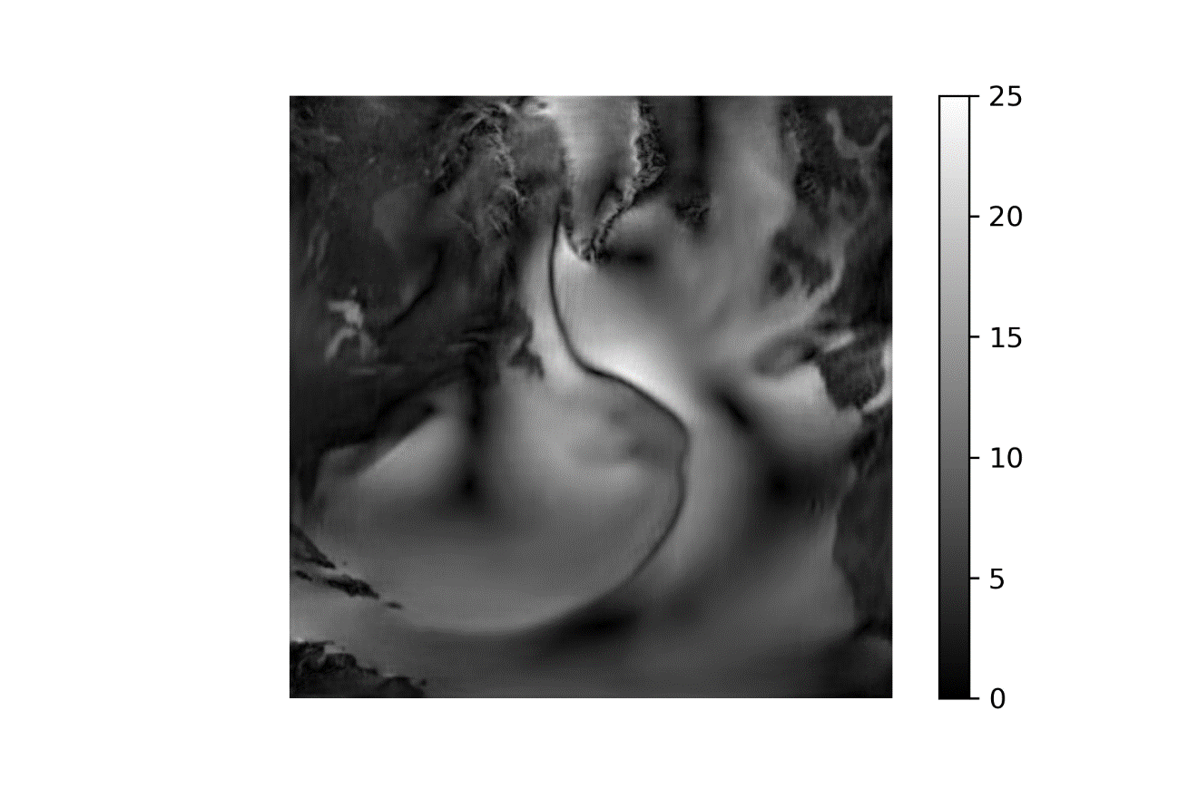



1 Jan 2010 –-SRGAN-1 - 50-150-350-High

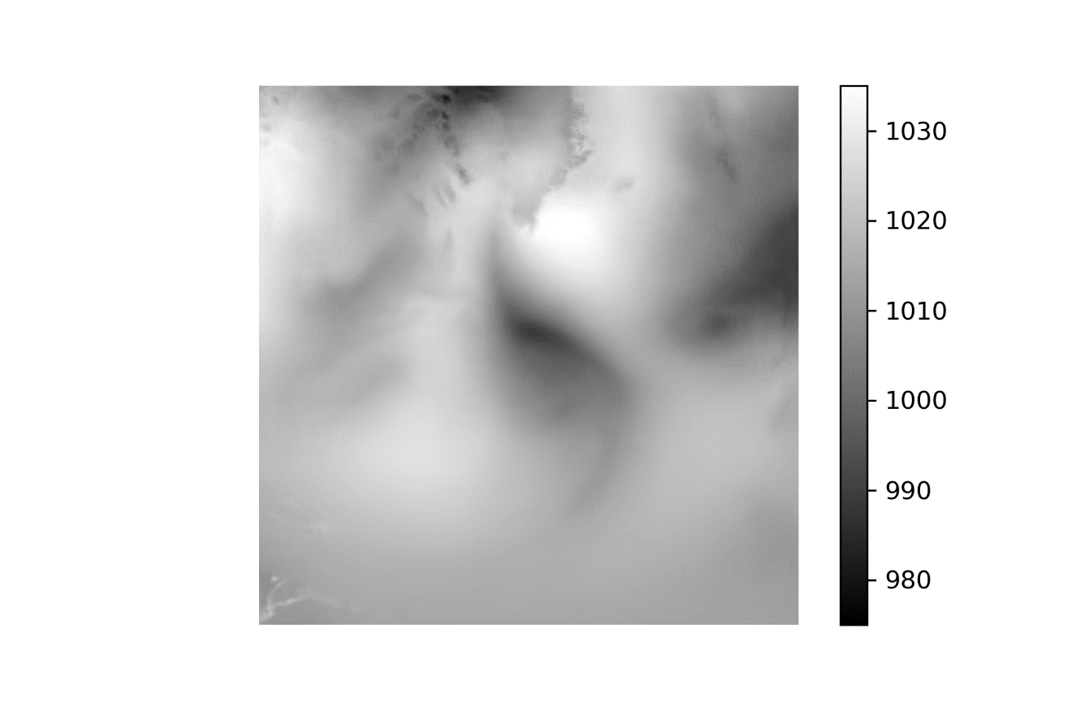



1 Jul 2010 –-50-150-350-High

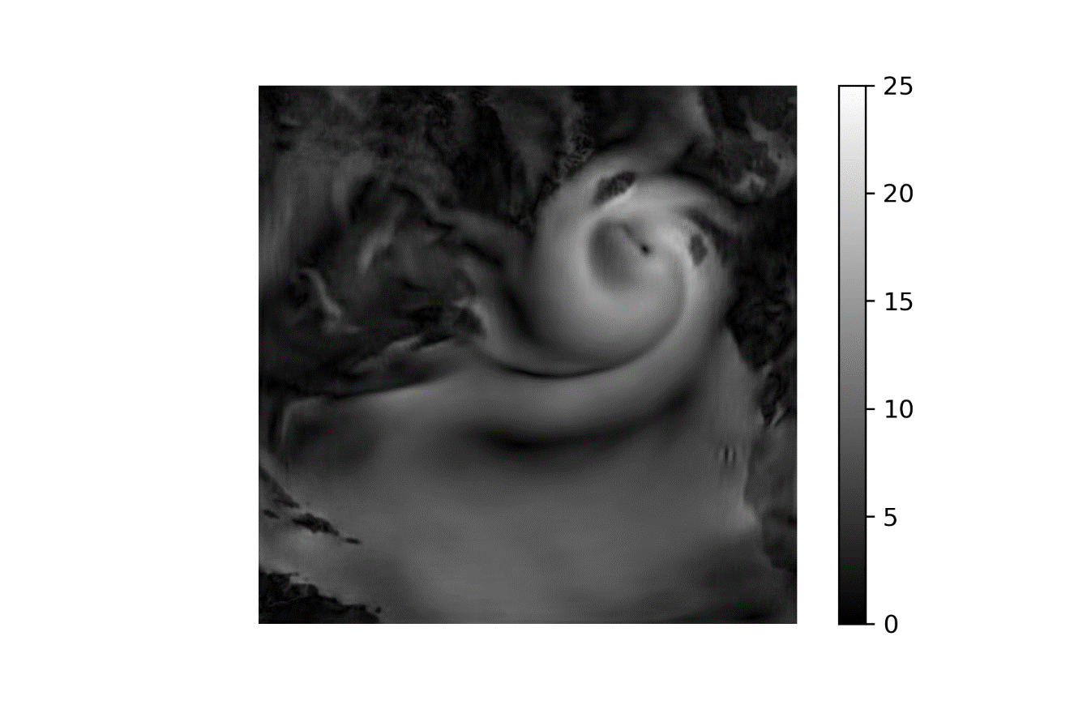



1 Jul 2010 –-50-150-350-High

